Entering Mayfield a few days after Christmas, the first thing sticking out to fresh eyes (and noses) are the stacks of smoke rising through the December sky. Piles of brush and massive trees snapped at the trunks expeditiously being burnt, making ingress and egress easier for large machinery and trucks to get through to further assess - and address – the recent damage. Wood smoke, typically a cozy, nostalgic fragrance, seems eerily heavy, emphasizing further destruction of a community already devastated.
We met Jody O’Neill, Executive Director of the Lighthouse Refuge for Women and Children in Mayfield, on an unseasonably warm December 28th. Many of the streets were still blocked by downed power lines, trees, smashed cars, and other heavy debris, so we followed her from a nearby church through side streets, makeshift cut-throughs, and parking lots until we were able to make it to the shelter. “The green letter x painted on the buildings – that means they’re ok to get torn down”, Jody mentioned as soon as we exited our vehicles. “You can see though – like right across the street – that some people aren’t ready to have their buildings and homes and what have you torn down, so there’s signs all over like that one over there asking crews to leave it standing.”
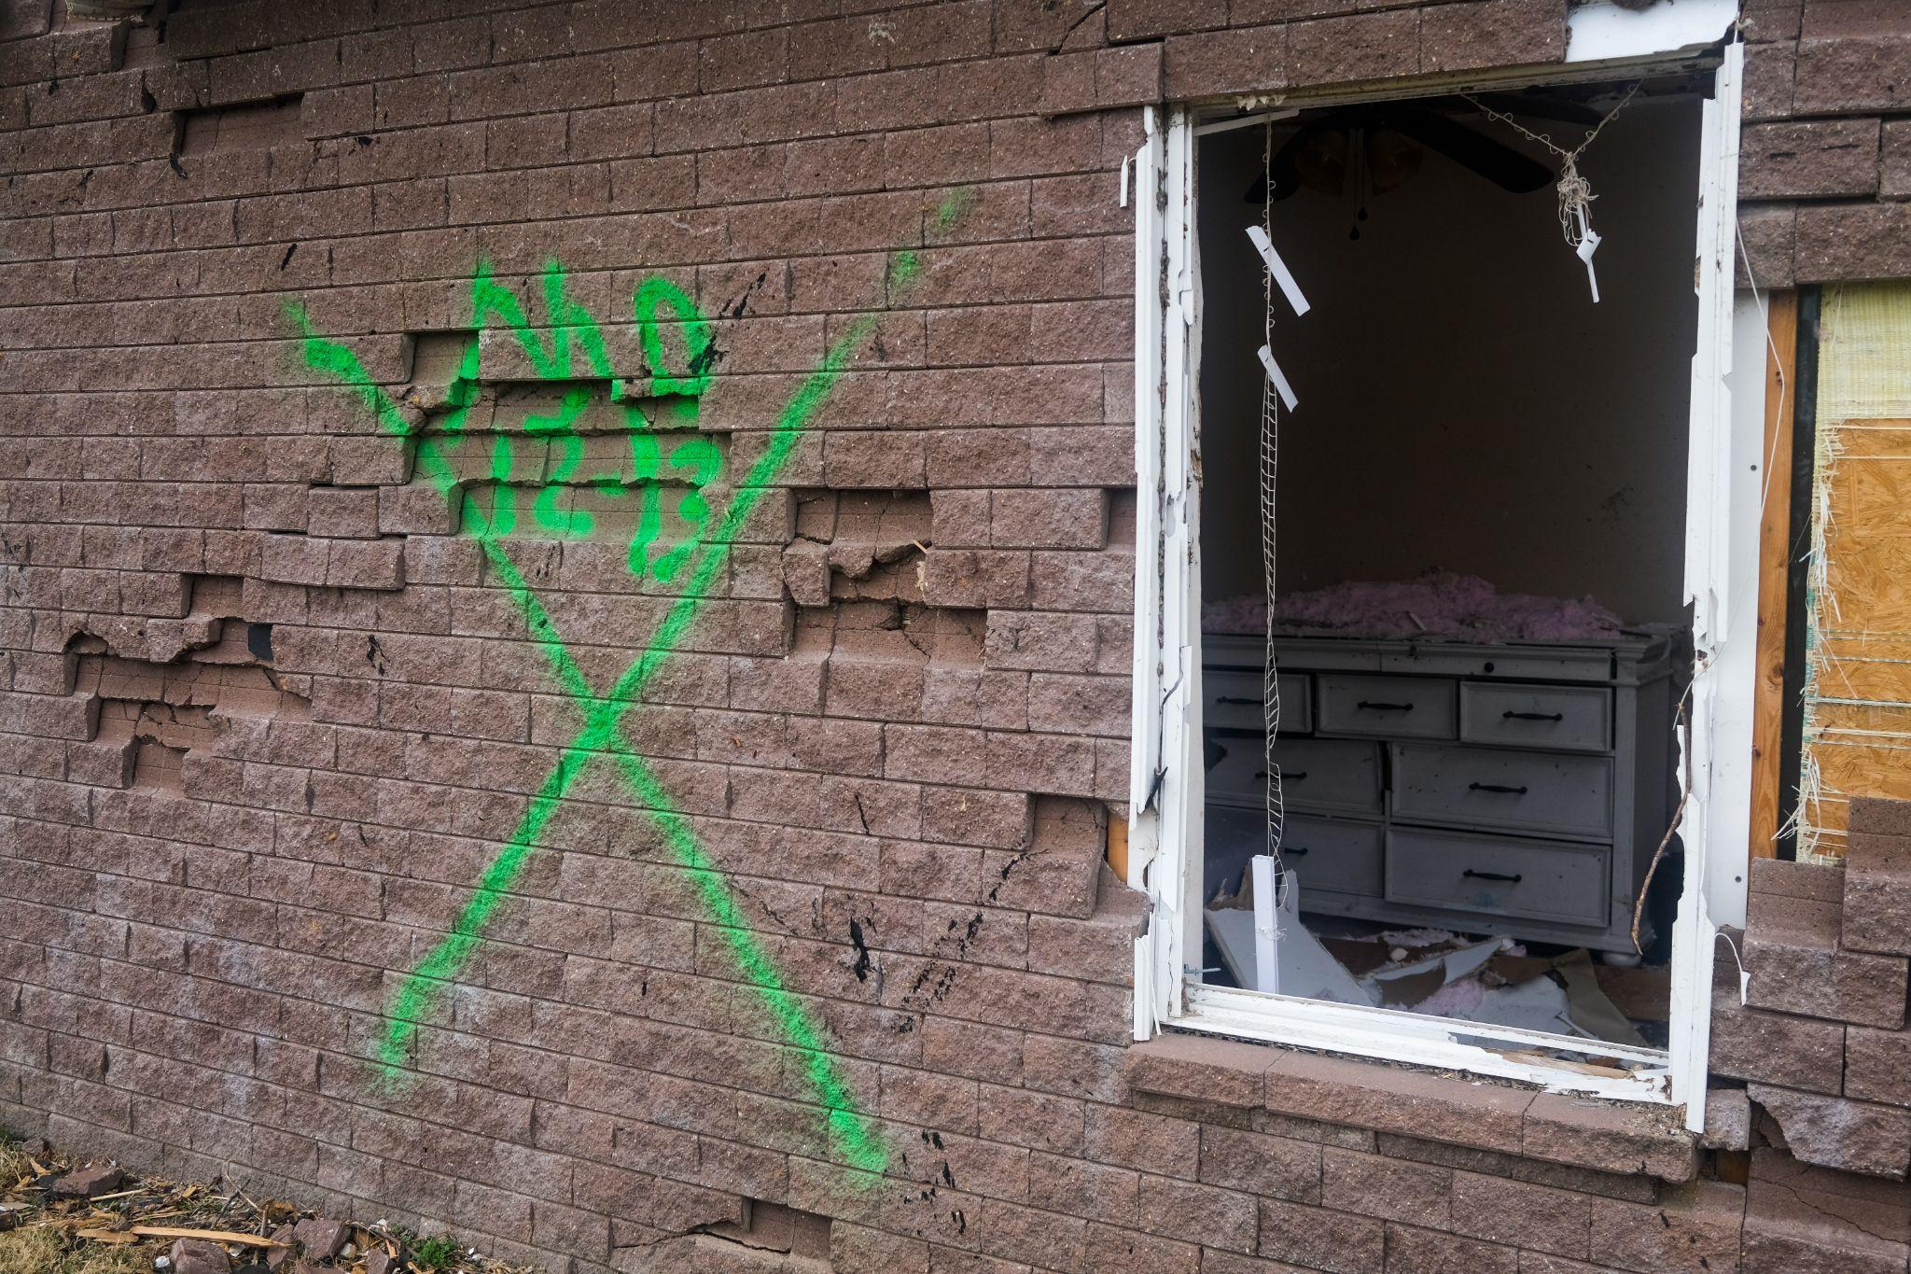
Green X marking The Lighthouse main building for demolition. Photo: Chet White

The destruction in Mayfield is so immense, so thorough, that it looks almost like a post-apocalyptic movie set. Like a room full of set designers came up with the descriptor “destroyed completely” and set builders went to work based on that. The Lighthouse is no different – destroyed from top to bottom, with little more than the outer walls still standing, and even those ready to topple at any minute.
Jody described the night of December 10th tearfully. Her voice, naturally gentle, had to be raised as we toured the remains of the shelter. There are no windows, no roof, and the wind whistles through the openings, making it difficult to hear. Clad in thick-soled boots, we stepped single-file carefully through push broom walkways that wound through piles of insulation, huge chunks of drywall, wires, and household items. “I get here and the sadness sets in. It just hits me and stays”, she began. In the background, backhoes and excavators beeped and roared, lifting huge trees, utility poles, and sides of buildings off the debris they covered. “My husband and I live about 10 minutes from here. Before I left for the day on the 10th, we [O’Neill and residents] went over the safety plans again and again, knowing there was some bad weather predicted. The conference room, the bedroom/bathroom, and the small staff bathroom are all interior rooms that we knew would be the best places just in case anything serious happened. To be honest, we just didn’t think it would, though.” She paused, making a gesture towards a room with a completely collapsed ceiling, the gray sky showing, instead. “We never thought any of it would be this bad. Just never.”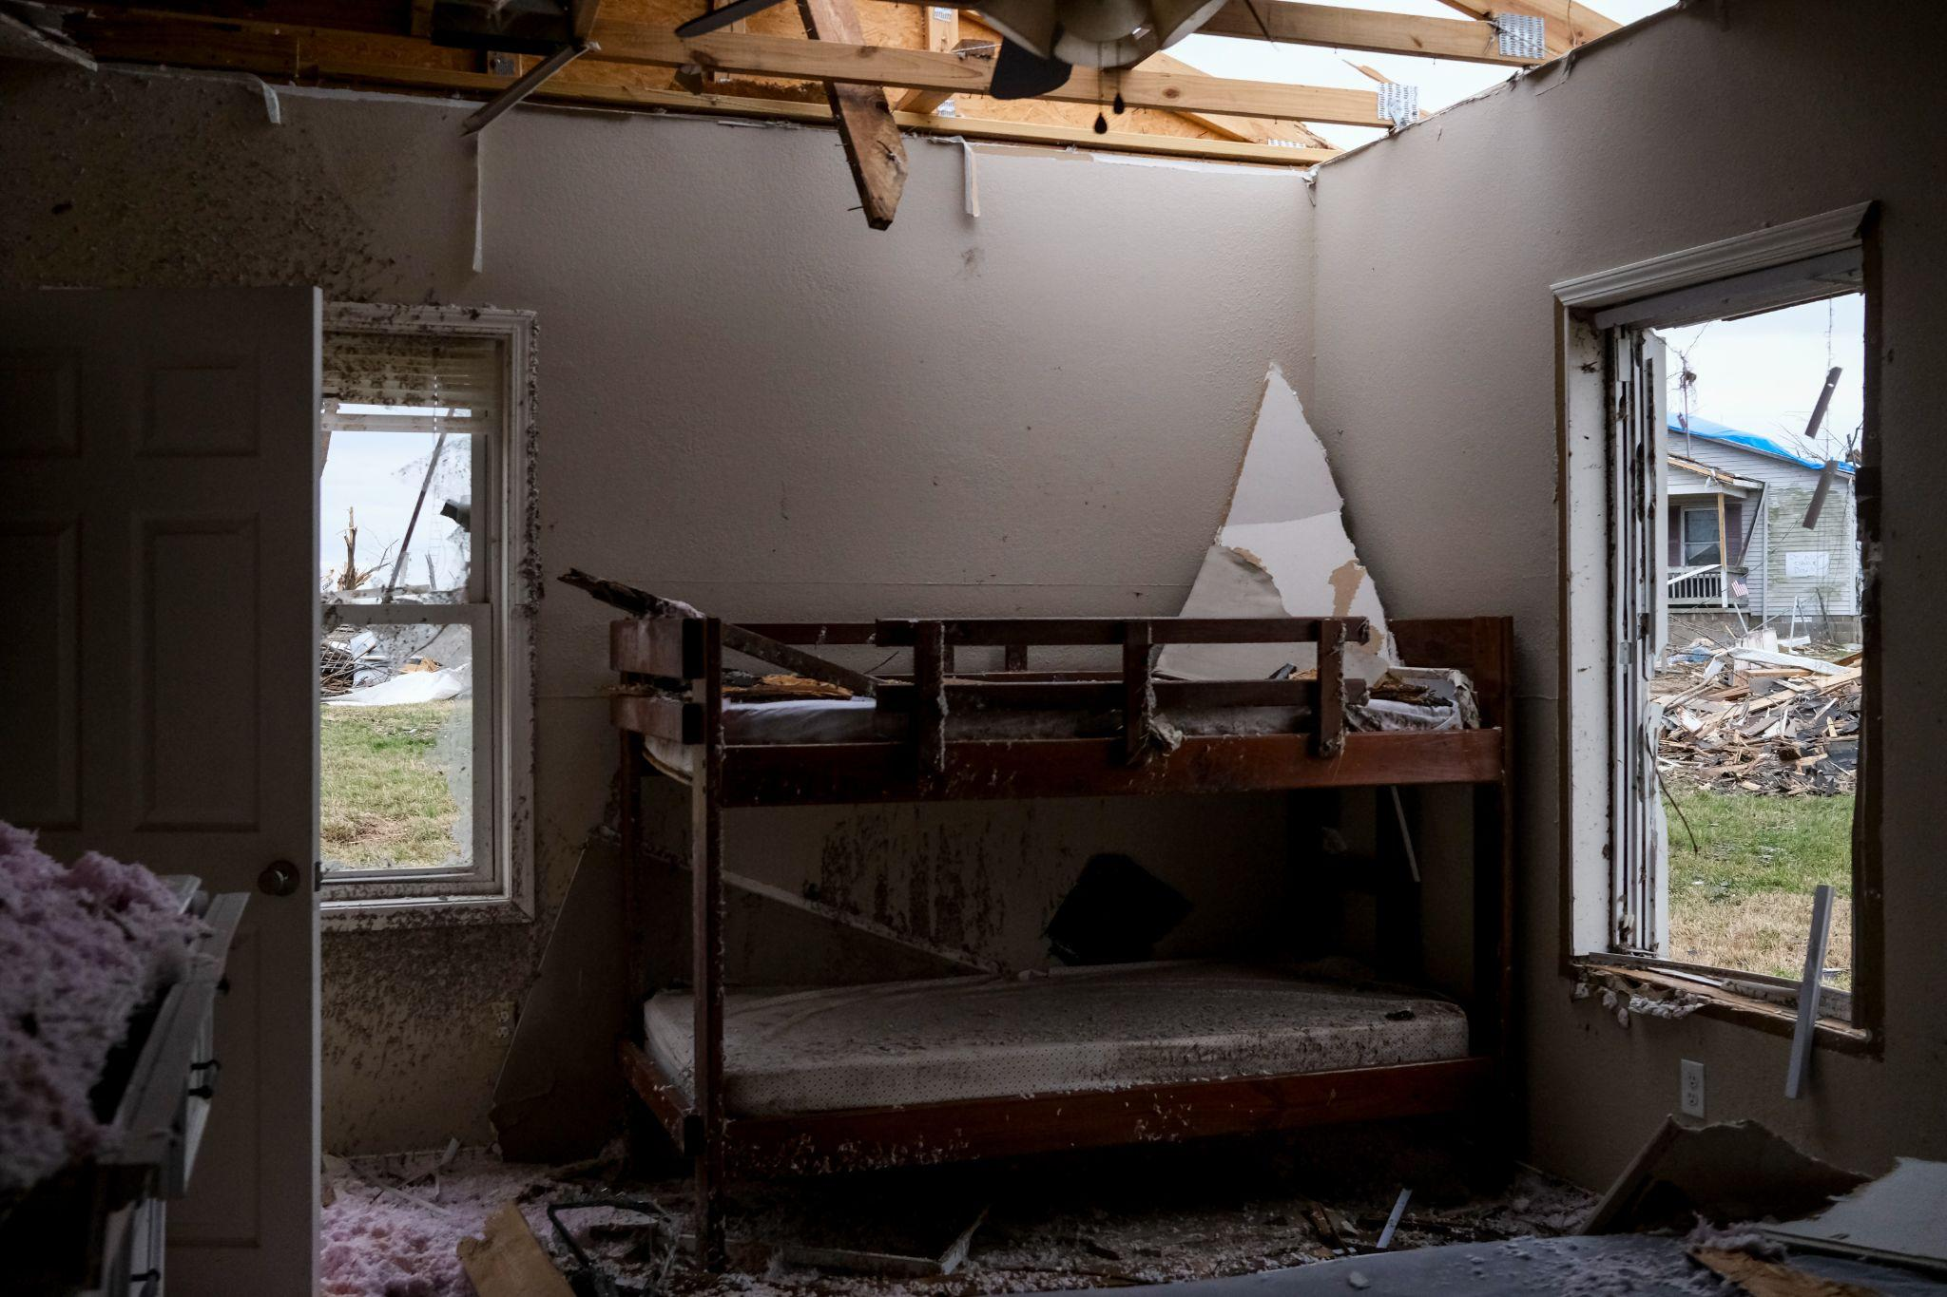
Childrens’ room inside The Lighthouse. Photo: Chet White

O’Neill became Director of The Lighthouse in 2020. “I wanted to make a difference in people's lives the last half of my life.I had previously volunteered at other shelters and when I left my previous job of 22 years, I had several calls the Lighthouse was hiring and that I would make a great Director. I stayed home from January 2020-April 2020 praying for direction from God, and I was contacted in April of 2020 about the position. I interviewed and accepted the position.” O’Neill speaks warmly of the clients she’s gotten to know over the years. Her care for them is maternal, genuine. “These ladies come and go, but we always keep in touch. They know they can always reach out here if they need to.”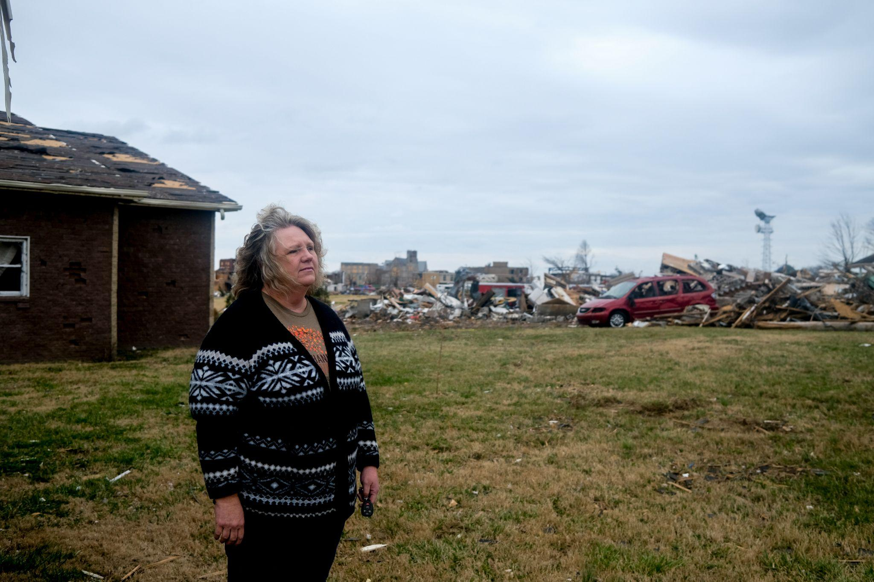
O'Neill in front of The Lighthouse. Photo: Chet White
Continuing through the rubble of the building, O’Neill went through the events of the harrowing night. Stopping at what suggested itself to have once been a large conference room, she gave a play by play of how residents survived. “Around 8:00 pm we [O’Neill and her husband] noticed it was getting windy so I called the residents and made sure everyone was dressed and watching the news. We communicated back and forth for the next hour and then my husband received a text from a friend that stated the tornado was coming down the highway by our house. We took cover, and I called the girls during this time and told them to get to any of the 3 safe places we talked about.” Checking her phone for accuracy, she continued “. . . and that was around 9:19 pm. They went into the conference room at 9:19 then they decided it was not safe. Around 9:25 I received a text that stated ‘you need to know our exact location in the house’. Six of us are in the bedroom/bathroom, and

[names redacted] are in the staff bathroom.” Stepping carefully through the debris, O’Neill pointed out what could barely be seen poking out of the rubble. “See that brown shelf looking thing?” she asked, gesturing at a mountain of debris including drywall, insulation, tin, wires, split ceiling joists, and more. “That table underneath all that – the thing that looks like a shelf sticking out - is the table the ladies were taking shelter under before they decided to move further inside. They would have been in here when the roof blew off if they’d stayed. I can’t even think about it.” Tearful again, giving pause to the weight of the moment, O’Neill gave a quiet thanks to God, and to the common sense of the residents who recognized the large room and table were not going to be adequate protection. “There were eight ladies living here when the storms hit. One of them has a little boy – he is so sweet – age 5. He was visiting his daddy and we are so grateful for that, you know? What a good time for him to be gone.” Surveying the missing roof and collapsed walls, “. . . [he] would have been so scared to be here during this, it’s really a blessing he was gone.”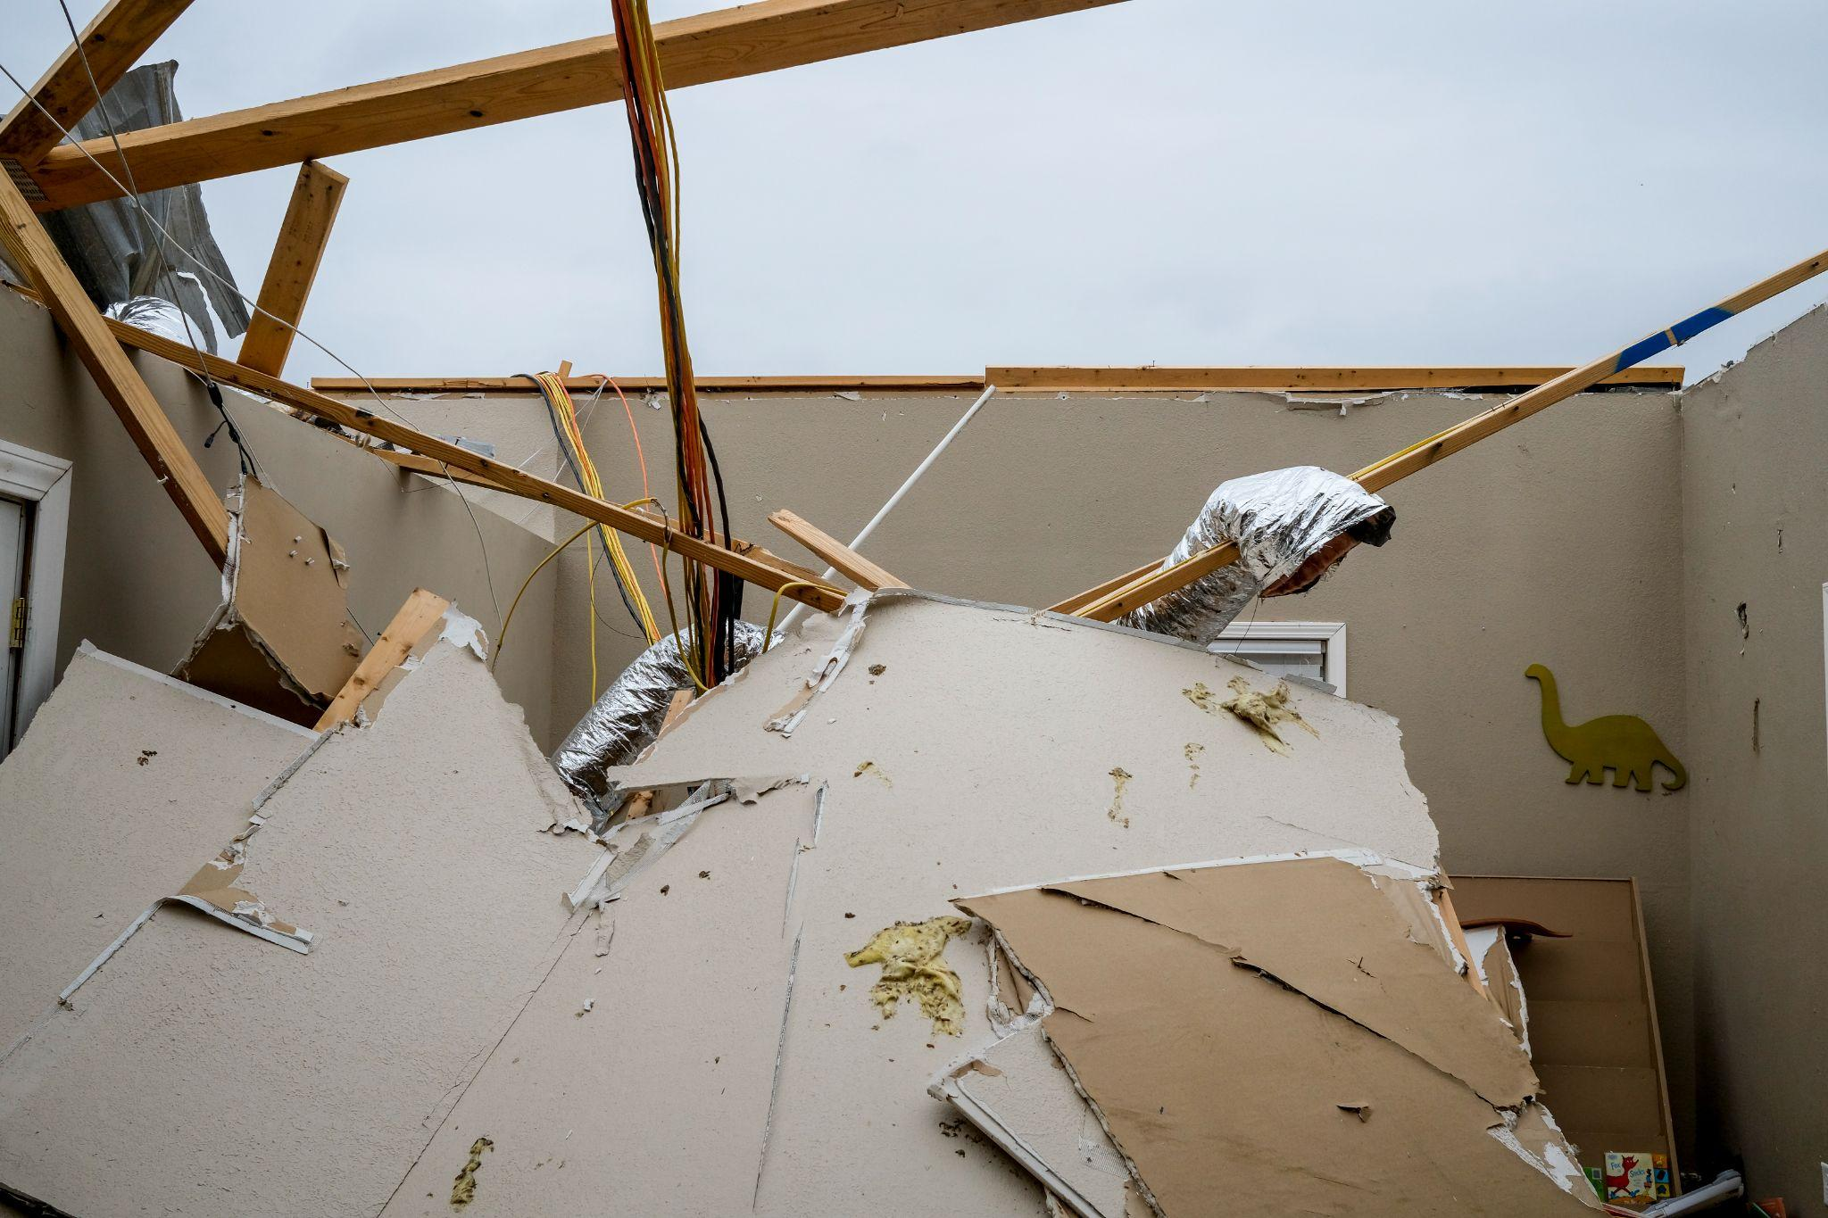 Collapsed ceiling at The Lighthouse. Photo: Chet White
Mayfield is a small town in Graves County, Kentucky. Deeply rural, the western Kentucky town had a population of 10,017 following the 2020 census. The Fair Market Rate of rent for a 2-bedroom house or apartment was $631 at the same time. While the cost of living is low comparatively speaking, the catch is that affordable rental units – before the tornado – were incredibly difficult to come by. Since the damage was inflicted, even more of the already scarce units have been made unavailable, making finding a new place to live

next to impossible. The next practical - though not desired - option is to move away. “One of the worst parts about this is that it’s going to be hard for some of them to stay local, and that’s a big part of their success once they leave here – being able to stay in the community where they’ve made relationships, got their kids in school, all that. There was not a whole lot of open, available, good housing around here, anyway. It was a struggle, anyway. The ladies would have to get on a waitlist for it [Section 8] and stay on it for months, for years. I’m really concerned that that’s gonna become an even greater issue now, with this, after this.”
About 45 minutes into our visit to The Lighthouse, a small, rugged SUV pulled up atop some of the debris in the used-to-be-a-parking-space space. Three people got out, all equipped with clipboards and holding cell phones. They were volunteers with the Red Cross, using GPS pins and written detail to create new maps of the areas of destruction for volunteers, construction/deconstruction crews, utility companies, law enforcement, etc., to use. Street signs were askew, if present at all, and buildings of note were destroyed, making getting around difficult if you didn’t know where you were. “A rumor going around is that a lot of the landlords, trailer park owners – the rental property owners – aren’t going to rebuild units. They’re gonna take the insurance payout, clean up the lots, and put them up for sale”, O’Neill informed. “And then what? There’s already almost nowhere to go if you’re looking for cheap.” 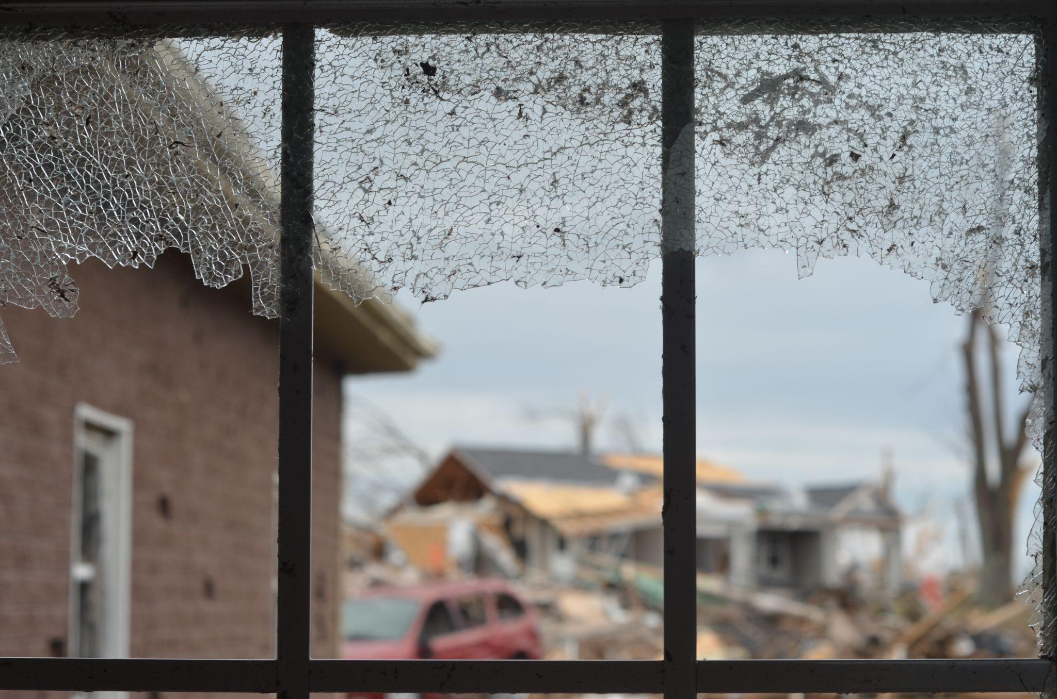

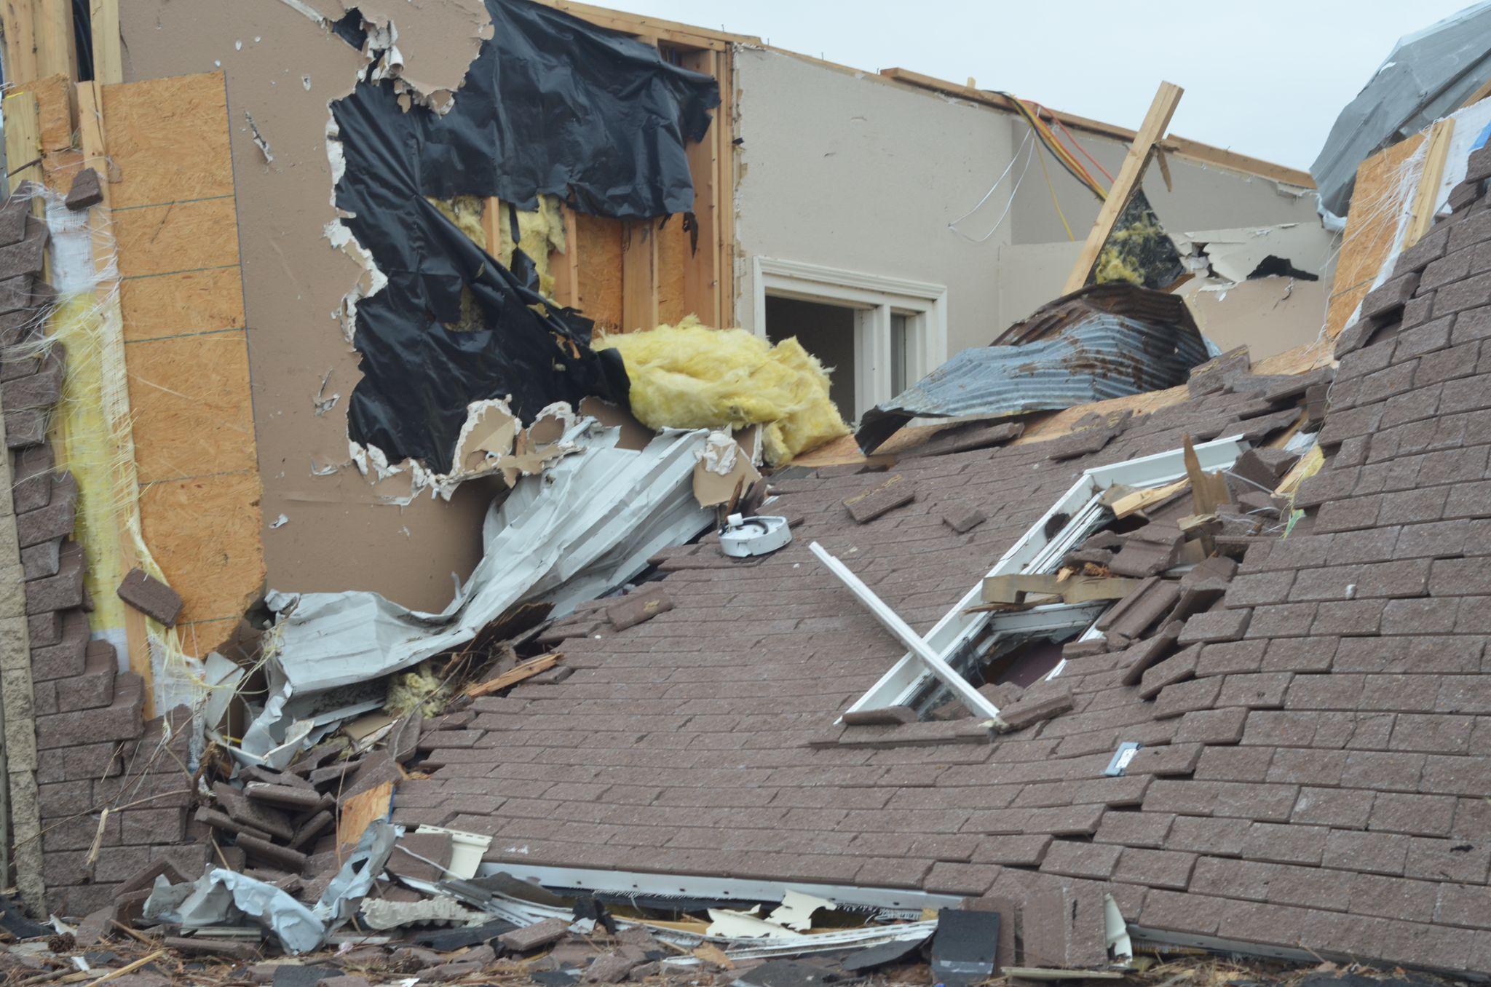
Remnants of the dining room, front porch, and entrance to The Lighthouse. Photos: Katherine Mueller
At the time of this piece, KHC listed two available units, both 1-bedroom apartments, for rent in Graves County under the ‘tornado response’ tab of their webpage. According to KHC staff, the site is updated twice a week, and available for anyone to use. “We’ve had some success reaching out to property owners in WKY”, said Joseph Pritchard at KHC. Still, while other tornado damaged counties such as McCracken and Warren have more units available (21 and 32, respectively), leaving the community where the rebuilding of their lives had begun is inevitable. “They’re gonna have to leave”, O’Neill lamented. “There’s just…nowhere to go. Even the volunteers have gone mostly now - they’re leaving and we know they won’t come back. Same will probably go for these gals [The Lighthouse residents].
After the devastating tornadoes of spring 2012 in West Liberty, Kentucky, population dropped immediately, and severely. With infrastructure and residential buildings destroyed, citizens moved west to Central Kentucky, and east to West Virginia. This is commonplace for small towns after large scale natural disasters - West Liberty is only now back to pre-tornado population levels (3,595 in 2020 as compared to 3,435 in 2010). Mayfield will likely be no different, especially since the town’s largest employer, Mayfield Consumer Products - a large candle factory- was destroyed completely during the storm. It is too soon to know the immediate impact of population detraction, but it is certain that with the absence of so many housing units and

employment, low wage workers - who often use Section 8 vouchers and live in low income housing - will have to leave in search of places to live and jobs, leaving even less reason for current landlords and rental property owners who own those units and buildings to rebuild and replace their units. Adding to this the destruction of the shelter, and the situation becomes more bleak for those in search of low cost, affordable housing.
A few weeks after the interview, O’Neill followed up to share that the Board of Directors at The Lighthouse decided to terminate the shelter as a functional residential organization for two years as they figure out how to clean up, redesign, and rebuild with the funds they have - and how they will operate with the predicted decrease in donations that will come as town population decreases, and many business owners and residents have less to share after incurring their own huge losses. O’Neill, undeterred, remains hopeful that although her position - like all paid positions at The Lighthouse - was “put on hold”, the church and non-profit communities would come together, over time, to regroup, and once again be able to offer housing and social service solutions to those who need them in Graves County and surrounding communities. What she was not sure of, what can not be predicted, and what may be most important to the reeling county seat, is if property owners, altruistic developers, and rental unit management companies will also re-invest in Mayfield, making it habitable for members of all tax brackets again. The struggling Build Back Better agenda put forth by the Biden Administration has language and earmarked monies for affordable housing updates all across America. Mayfield would no doubt benefit from that influx of cash, but it will be up to lawmakers and policy writers, local developers and property owners to see that to fruition. In the meantime, the low and extremely low income residents of Mayfield will disperse to surrounding counties - many not for the first time - in search of decent places to live, work, and a place to call a new home.

